Employee effort and productivity in organizations: A network data science approach

7/16/17

**Nan Wang; Evangelos Katsamakas**

# Abstract

Estimating the performance of employees is an important consideration in all organizations. This paper proposes a network data science approach to the estimation and visualization of employee effort, productivity and collaboration patterns. Using data from a software development organization, a bipartite weighted network is firstly constructed for developers’ commitment to project repositories. It is afterwards projected into two weighted one-mode networks: developer-to-developer and repository-to-repositories. For the former graph, two developers are defined to be connected if they once shared projects and for the latter, two repositories relate with each other if sharing developers. Techniques applied include graph theoretic metrics, power-law estimation, and community detection algorithms. We validate the existence of power-law relationships on project sizes (number of developers). We discuss implications for managers and future research directions. As a methodological contribution, the paper demonstrates how network data science can be used to derive a broad spectrum of insights about employee effort in organizations.

**Keywords:** networks, data science, network analysis, network science, ~~power laws,~~ employee effort, productivity, collaboration

# Introduction

Estimating the performance of employees is an important consideration in all organizations. This paper proposes a network data science approach to the estimation and visualization of employee effort, productivity and collaboration patterns.

While the methodology can be used in any type of organization, the data we use to illustrate an application of the methodology come from a software development organization. Software application development has turned into an enormously profitable business, with revenue from mobile application purely expected to exceed fifty billion USD by 2016 [1]. Accurate evaluation of developers’ achievement and contribution has been proved to be critical for the long-term development of companies as it is directly related to employee morale, overall productivity and creativity. Poor capability to discover and monitor coding performance prevents technical companies from transforming information on network activity and infrastructural capabilities into strategic knowledge [2, 3].

(REMOVE THIS PARAGRAPH FROM INTRO; ADD IT LATER IN PAPER IF NECESSARY) Although extensive historical study has applied social network analysis as a powerful solution to help understand organizational network performance and service interaction [4], most of them were designed in the context of binary networks. However, many real-life networks are widely recognized to be intrinsically weighted. Characterizing features and structures in weighted networks, therefore, has more important practical significance [5]. Bearing that in mind, this paper investigates a weighted bipartite network where developer is one mode and repository is another.

The questions we attempt to answer include identification of developers’ role, contribution, motivation, functionality and working preference, as well as in a broader sense, project membership, corporate cohesion, collaboration patterns and software development productivity.

We demonstrate how a network data science approach can help companies gain rich insights about these questions. We define network data science as the use of data science methods, tools and algorithms in the modeling and analysis of network (graph) data.

(WRITE A SUMMARY OF MAIN STEPS WE FOLLOW)

# Dataset and data preparation

The dataset used in this paper is the coding effort of 2621 developers to 1705 repositories in a real-life company in a period of 92 days, from July 1, 2015 to September 30, 2015. This panel data has four variables, namely date, Worker ID, coding effort, Repository ID. There are 172,354 records in total, where “Worker ID” and “Repository ID” identify each unique developer and project respectively. Data is gathered on past software development activity via source code repositories like Subversion and Git, and task tracking systems such as Jira. This dataset is kindly provided by the company BlueOptima. Table 1 shows a subset from the dataset.

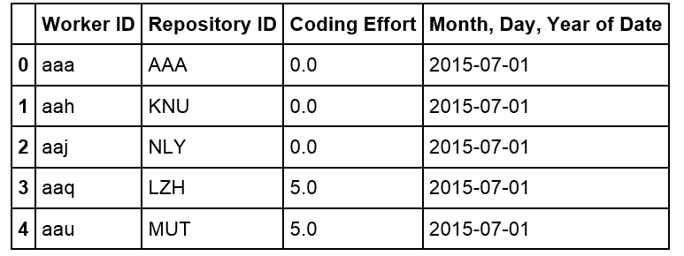

**Table 1.** Sample of original dataset. Coding effort is a proprietary software measurement and is calculated through evaluating every change that software developers contribute to projects in terms of a series of metrics, such as volume, complexity and interrelatedness of codes (Newswire 2013)

There are many records with zero coding effort in the data. It is resulted from the fact that if a developer is involved in a project, coding effort will be recorded regardless of the absence of contribution. Therefore, to keep the information of developers’ involvement, we remain all data records.

# Modeling Effort and Contribution: Developers-Projects Graph

When relations are modeled between two different classes of objects, bipartite graphs arise naturally. (Guillaume and Latapy 2004). A graph of customers and products, with an edge between a customer and a product, if the customer has bought that product, is a simple example of a bipartite graph.

To construct the graph, we aggregate each developer’s contribution to every repository. The graph therefore stands for a static developer-to-repository network, where developers belong to one mode and repositories another. Edges represent developers’ contribution to projects and are weighted by coding effort.

* 1. **Graph Properties**

To understand the properties of this network, we apply a measurement called degree centrality to the graph. (Newman 2010)

Degree is the number of ties that a node has. In the developer-repository situation, nodes with degree of one can be interpreted as “focused developers” who worked on only one project, or individual project which contained only one developer. It is found that during the entire period in concern, over 50% developers (1409 out of 2459) devoted to only one project and above 40% projects (610 out of 1496) were individual projects. In addition, the maximum degree is 39 for all developer nodes and 96 for repository nodes, meaning that the most multiple-tasking developer (Developer “ouj”) contributed to 39 projects and the largest project (Project “KGD”) were contributed by 96 developers. Also, the average degree is 2.3 for worker nodes and 3.8 for repository, meaning that, overall, each worker worked on two projects and each repository contained four workers.

With most projects being small and a few large, it is reasonable to conclude that sizes of projects are polarized, indicating that the company’s software development business is a combination of a few principal projects and plenty of small projects. Moreover, if developers’ roles can be implied by the number of projects they work on and the contribution they make, for example, managers tend to distribute their contribution in a wider range of projects, we are probably able to see the workforce allocation. As it shown in Figure 1, developer nodes with large degree (many projects) but small-weighted edges (small contribution per project) can possibly be interpreted as project managers, while nodes with small degree (small project volume) and small-weighted edges (small contribution per project) can be considered as unproductive workers.

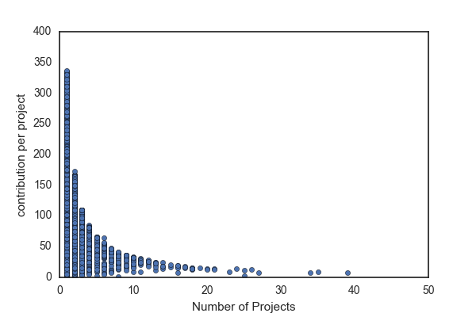

**Senior manager**

**Manager**

**Unproductive**

**Figure 1.** Roles and productivity based on node degree and edge weight

* 1. **A Graph Recommender System**

Recommender systems have been created for various data science applications in a variety of areas (Francesco Ricci, Lior Rokach, Bracha Shapira 2011). For example, Facebook utilizes recommender systems to suggest friends to users, iTunes and YouTube utilize similar machine learning and recommendation algorithms to suggest songs, videos and movies. Given this general theme, we attempted to create a recommender system to suggest the assignment of developers to projects.

Collaborative filtering (CF), one of the most popular ways to implement recommender system, is a method of making [predictions](https://en.wikipedia.org/wiki/Prediction) or recommendations (filtering) about the interests of a user by collecting preferences or [taste](https://en.wikipedia.org/wiki/Taste_(sociology)) information from [many users](https://en.wikipedia.org/wiki/Crowdsourcing) (collaborating). There are three major types of collaborative filtering algorithms in the recommender system literature, namely memory based approaches (uses user rating data to compute the similarity between users or items), model based Approaches (uses [data mining](https://en.wikipedia.org/wiki/Data_mining), [machine learning](https://en.wikipedia.org/wiki/Machine_learning) algorithms to predict users' rating of unrated items), as well as hybrid approaches (combines the memory-based and the model-based algorithms). Each of those approaches has its own advantages and limitations (Francesco Ricci, Lior Rokach, Bracha Shapira 2011; John S. Breese, David Heckerman, Carl Kadie 1998).

In the situation of developers’ contributing to projects, developers can be modeled as users in the recommender systems. Similarly, projects can be modeled as items and coding effort are ratings. The choice of modeling methods is usually affected by the data available and the purpose of recommender systems. Considering that our recommender system is to make recommendations rather than predictions, and content data (data describing users or items) is unavailable, we’ve chosen to apply memory based approaches.

Memory based approaches has advantages including content-independence, easy implementation and intuitive interpretation. (John S. Breese, David Heckerman, Carl Kadie 1998). However, it is sensitive and vulnerable to large sparsity data. Given the fact that in our case, there are 2621 users and 1705 items, and over half of users rated only one item, the data is expected to be sparse.

One of the common ways to address sparsity is to apply hybrid approaches. For example, use principle component analysis to compress a high dimensional user-item matrix containing abundant number of missing values into a much smaller matrix in lower-dimensional space. While overcoming the problems of sparsity and loss of information, this method is complex and expensive to implement.

Therefore, instead of hybrid approaches, we turn to graph to address the problem of data sparsity. We firstly define that two users are neighbors if they share at least one item. In other words, two developers are neighbors if they work on at least one project. Instead of computing similarity of every two users, we only do calculations between neighbors.

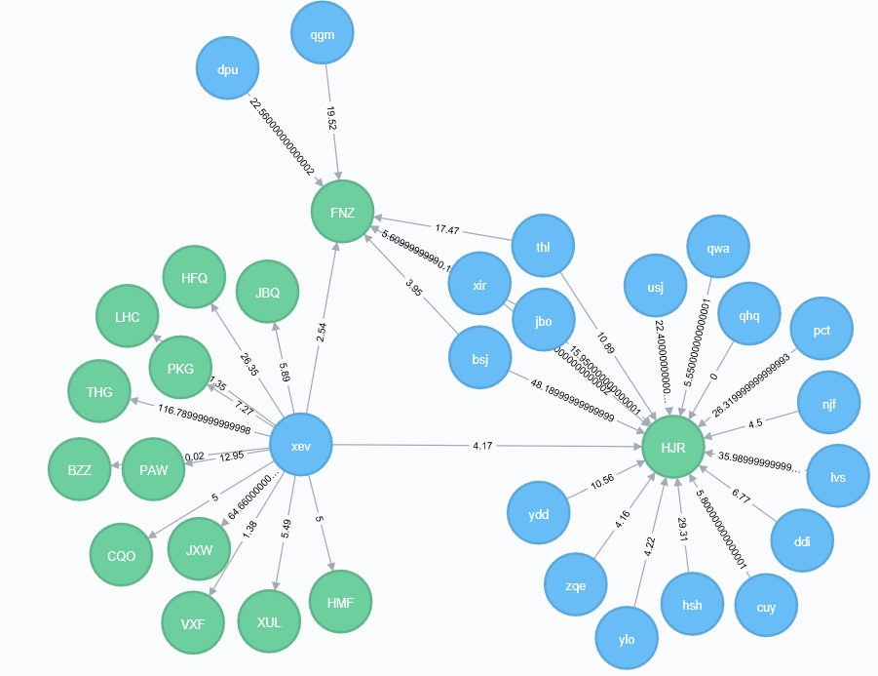

**Figure 2.** ‘XEV’ is neighbored with both ‘dpu’ and ‘bsj’, by sharing the one project with the former and two with the latter.

To define the similarity of ui to u1, the following function is applied:

Number of Common Projects between u1, ui

Sim(u1, ui) =

Number of Projects of ui

The similarity of ui to u1 is the ratio of the number of projects they have in common over the number of projects ui works on. We further set a threshold of 0.5 for similarity, which means that developer ui is considered to be similar to developer u1 only if u1 work on at least half of ui’s projects.

We can afterwards make recommendations by answering either the question of what projects popularly shared by similar neighbors, or what projects actively contributed by similar neighbors.

Table 2 is a list of projects recommended by the system to the developer ‘xev’:

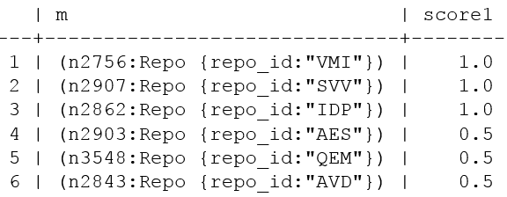

**Table 2.** Recommender system with similarity threshold being 0.5

The scoring function calculates the ratio of similar neighbors who contribute to the recommended project over those who don’t. Assuming a manager is about to assign the developer ‘xev’ a familiar project, ‘VMI’, ‘SVV’ and ‘IDP’ would be worthy of consideration, given the fact that all xev’s nearest neighbors have worked on them.

Table 3 is another list of projects recommended by the system to the developer ‘xev’. Different from the previous system, the scoring function has changed into the sum of similar neighbors’ contribution. Therefore, the system recommends new projects to the developer ‘xev’ in an order from ‘contributed the hardest by similar neighbors’ to ‘contributed the least by similar neighbors’. If a manager wants to ensure developers’ contribution when assigning new projects, he probably prefers this recommendation scheme based on the assumption that a developer will contribute to a project in a comparable way as his similar developers. If nearest neighbors unanimously work hard on a project, the developer is likely to devote too.

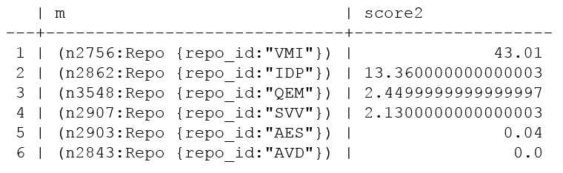

**Table 3.** AnotherRecommender system with similarity threshold being 0.5

More insights can be retrieved if the results of both recommender systems are combined. For example, although both project ‘VMI’ and ‘SVV’ are participated by all the nearest neighbors of developer ‘xev’, the former receives massive contribution while the latter has little. Also, although half of nearest neighbors participate in the project ‘AVD’, none of them contribute anything in the concerning period.

Furthermore, we’ve found that different similarity threshold would affect recommendation results largely. For example, if we change the similarity threshold to 0.4, as shown in table 4, the results would be as follows and ‘VMI’ was the only project shared by all the developer’s nearest neighbors.

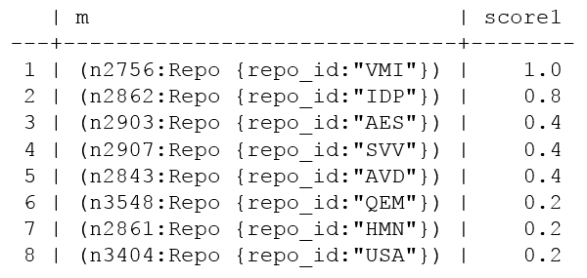

**Table 4.** AnotherRecommender system with similarity threshold being 0.4

An optimized graph-based recommendation system is beyond scope of this paper. Here we just implemented a general-purpose way to demonstrate the simplicity and scalability of a graph-based approach. It doesn’t necessarily require user features or large volume of data for training. Moreover, it helps solve the data sparsity and computation problem of memory-based approaches.

* 1. **Conclusion**

With the weighted bipartite developer-project graph, we gain an overview of the structure and workforce allocation of the company’s software development business, as well as build an efficient graph-based recommender system which facilitates the project assignments of different purposes.

# Modeling Collaboration: Developers-Developers Graph

When relations among only one class of objects in a bipartite graph are needed, projection is usually applied to transform the graph from two-mode into one-mode (Zhou Tao, Ren Jie, Matus Medo, Yi-Cheng Zhang 2007). The process works by selecting one set of nodes, and linking two nodes if they are connected to the same node of the other set. However, since one-mode projection is always less informative than the bipartite representation and the redistribution of weights would strongly affect the community structure, a proper weighting method is required to better retain the original information.

In this paper, Newman’s weighted projection (Newman 2001) is applied, which adopts the weighting scheme presented by Newman. This method creates a one-mode network in which the out-strength of a node is equal to the sum of the weights attached to the ties in the two-mode network that originated from that node.

Accordingly, the developer-to-repository graph is projected into two separate one-mode graphs. One is a developer-to-developer graph with 2459 nodes and 61378 edges where each developer is a node and an edge exists between two nodes if both developers are on the same project, and another is a repository-to-repository graph with 1496 nodes and 16764 edges where repositories are nodes and edges represent shared developers.

* 1. **Graph Properties**

With the one-mode developer-developer graph, we can then elaborate on developers and their connections through studying properties of the developer-developer graph.

* + 1. **Degree Centrality**

We firstly apply degree centrality and plot out the distribution of degrees. Figure 3 shows that the degree distribution appears to follow a power-law distribution. (Clauset, Shalizi and Newman 2009). In the network theory, a network is named scale-free if its degree distribution follows a mathematical function called a power law. (Albert and Barabasi 2002). Unlike a random graph (i.e., new nodes attach to existing nodes with uniform probabilities), a scale-free graph displays preferential attachment of new nodes (i.e., some nodes have higher probability of attachment than others). In our developer-project case, it is intuitive that the network was not randomly formed. It is also in accordance with expectation that a developer, if having diversified skillsets or senior experience, was likely to collaborate with more developers.

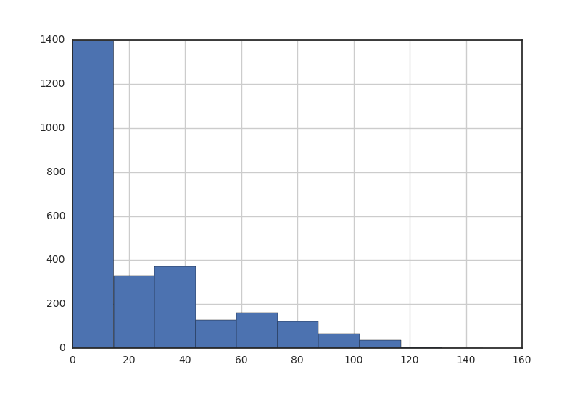

**Figure 3.** Node degree distribution for developer graph

To validate our assumption that nodes in the graph have preferential attachment, we applied a Statistical analysis called Kolmogorov-Smirnov test. (Hazewinkel and Michiel 2001) Test results are as follows. The combination of small test statistic (KS.stat) and bigger p-value (KS.p) together indicates a good fit of power-law distribution [23, 24]. As it shown in Table 5, KS.stat is 0.074 and KS.p is 0.99. It therefore proves that the developer-to-developer network has the property of scale-free. (Marsaglia et al 2003)

|  |  |  |
| --- | --- | --- |
| **Measurement** | **Definition** | **Value** |
| Alpha | The exponent of the fitted power-law distribution. | 18.67 |
| xmin | The minimum value from which the power-law distribution was fitted. | 206 |
| logLik | The log-likelihood of the fitted parameters. | -45.63 |
| KS.stat | The test statistic of a Kolmogorov-Smirnov test that compares the fitted distribution with the input vector. **Smaller scores denote better fit.** | 0.074 |
| KS.p | The p-value of the Kolmogorov-Smirnov test. Small p-values (less than 0.05) indicate that the test rejected the hypothesis that the original data could have been drawn from the fitted power-law distribution. | 0.99 |

**Table 5.** Statistical tests for power-laws

* + 1. **Shortest Path Length and Closeness Centrality**

Shortest path length is the number of steps along the shortest paths for all possible pairs of network [nodes](https://en.wikipedia.org/wiki/Node_(networking)). (Clauset, Shalizi and Newman 2009) Figure 4 shows the distribution of shortest path length in the graph. Averaged at 4.86, length of the shortest path ranges from one to thirteen, meaning that a developer might expect to reach a randomly-selected developer in a typical distance of five, and the distance could be as small as one and as large as thirteen in the company of 2,459 developers.

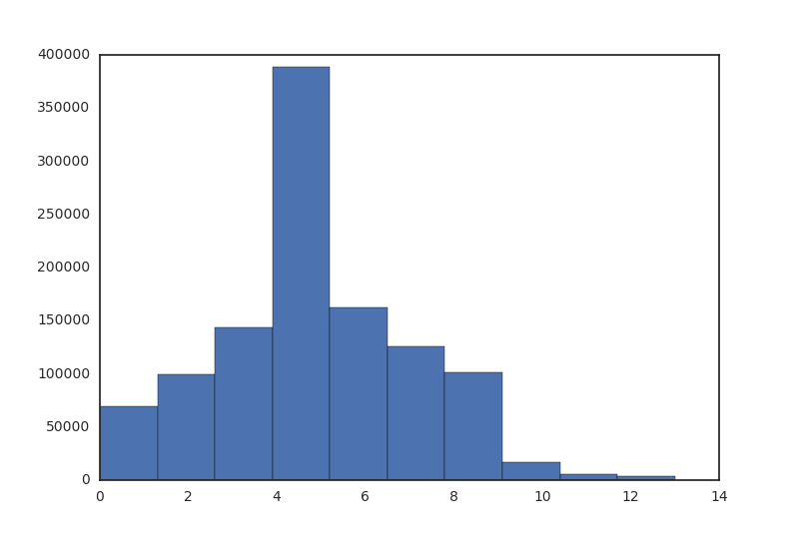

**Figure 4.** Distribution of Shortest Paths in the developers’ network

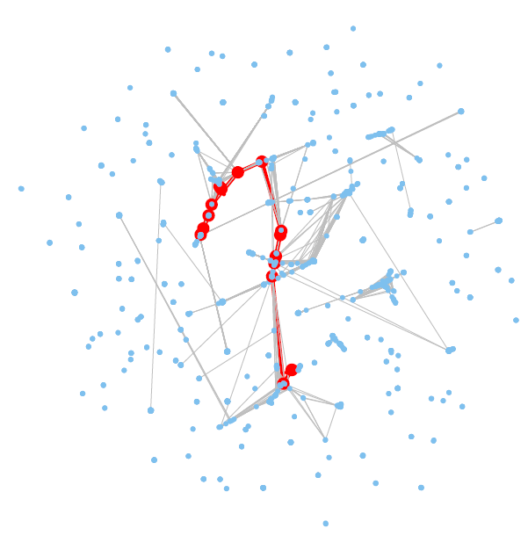

**Diameter: 13**

**Figure 5.** Visualization of developer network diameter

Closeness centrality, which uses the reciprocal of the average shortest distance to other nodes, is a measure of the degree to which an individual is near all other individuals in a network. (Clauset, Shalizi and Newman 2009) High closeness centrality therefore indicates close access to the resources in the network. In the developer-project network, developer 'rbp', 'kfx', 'agq', 'tel', 'erj', 'kov', 'cyc', 'uva', 'dpy', 'mff', 'puy' and 'cem' are top twelve individuals having closest access. Furthermore, from figure 7, we find that all of them work on project ‘OOT’ and ‘HFQ’. It can be therefore implied that project ‘OOT’ and ‘HFQ’ are projects gathering massive resource and by working in both, developers are able to get closer access to recourse.

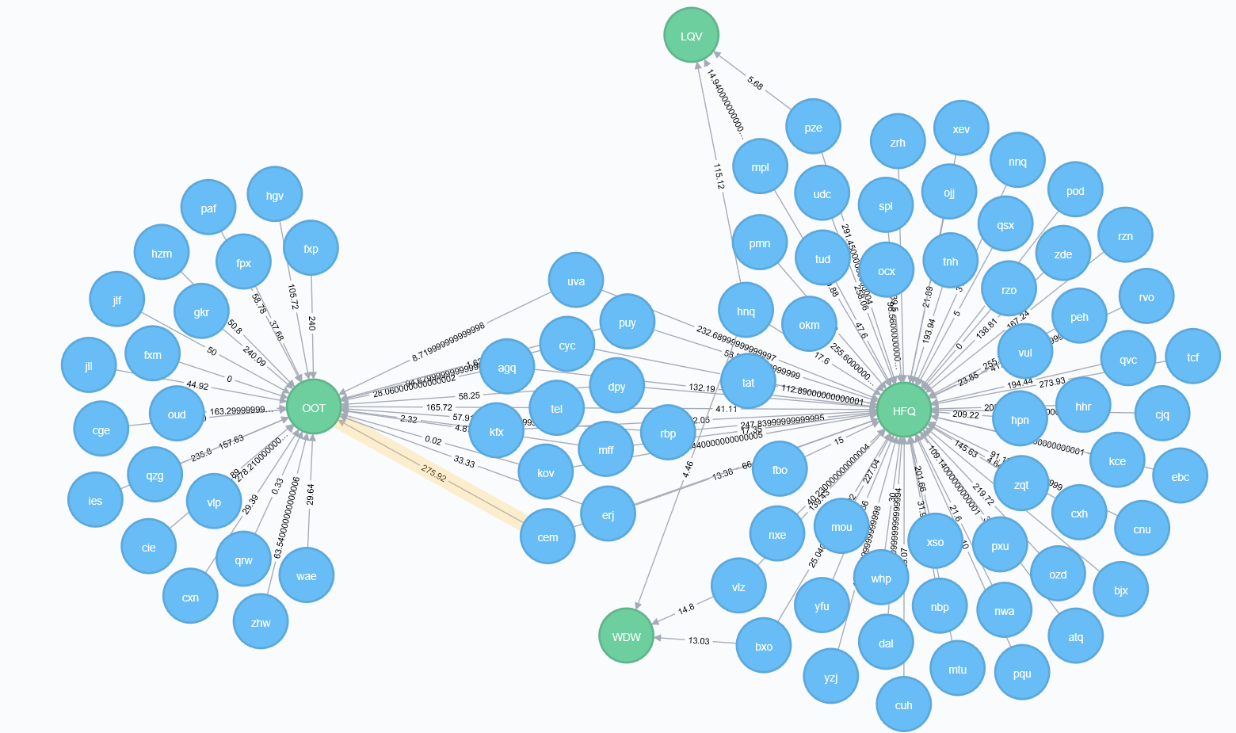

**Figure 6.** Project ‘OOT’ and ‘HFQ’ are shared by developers who have the highest closeness centrality.

In terms of nodes with smallest closeness centrality, as it shown in figure 7, they all exclusively engage in one individual project.

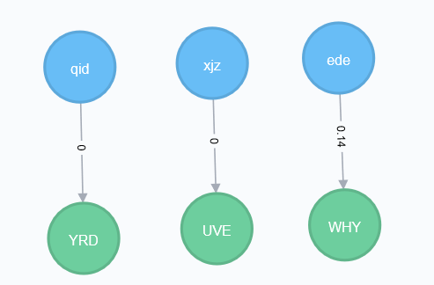

**Figure 7.** Developers with lowest closeness centrality and their relationship

* + 1. **Betweenness Centrality**

Betweenness centrality for each [node](https://en.wikipedia.org/wiki/Vertex_(graph_theory)) is the number of these shortest paths that pass through the node. (Clauset, Shalizi and Newman 2009) Nodes with higher betweenness scores therefore have more control of other nodes in terms of communication access. In the develop-developer network, developer ‘cge’ has the highest betweenness centrality. As shown in the figure 8, ‘cge’ is the only person working in both ‘OOT’ and ‘KGD’, two principal projects in the company. Thus, it is reasonable to infer that developer ‘cge’ plays a significant role for the information sharing in between.

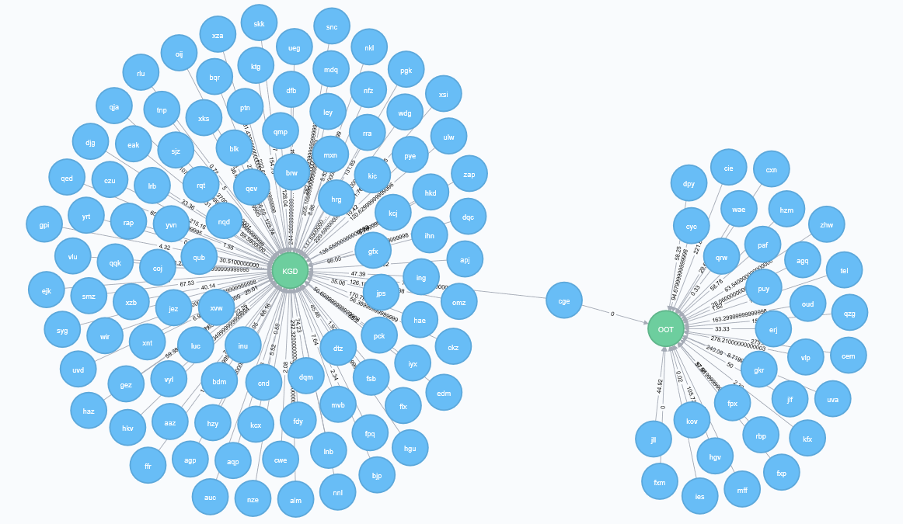

**Figure 8.** Developer ‘cge’ and corresponding connections

* + 1. **Eigenvector Centrality**

Eigenvector Centrality is a measurement revealing both neighbors’ quantity and quality. (Clauset, Shalizi and Newman 2009) In other words, a high eigenvector score is resulted from a large number of high-quality neighbors. High-quality developers can be described as those involving in one or several principal projects, or participating in diversified projects, by which they interact with many people in the network. Correspondingly, low-quality developers are those engaging in unitary or individual projects, by which they collaborate with few others in the network.

As shown in Figure 9, nodes colored in blue are those with highest Eigenvector. They are widely positioned among different subcomponents in the graph and are connected with different sets of nodes.

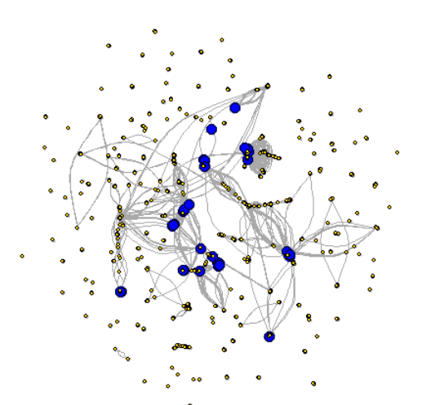

**Figure 9.** Visualization of developers with high eigenvector scores

Figure 10 is a scatter plot showing eigenvector centrality versus degree. We can see that most nodes has an eigenvector centrality of about zero. Also, although that ‘xev’ has more than three times of degree than ‘ouj’, ‘ouj’ has the largest eigenvector centrality while ‘xev’ the least.

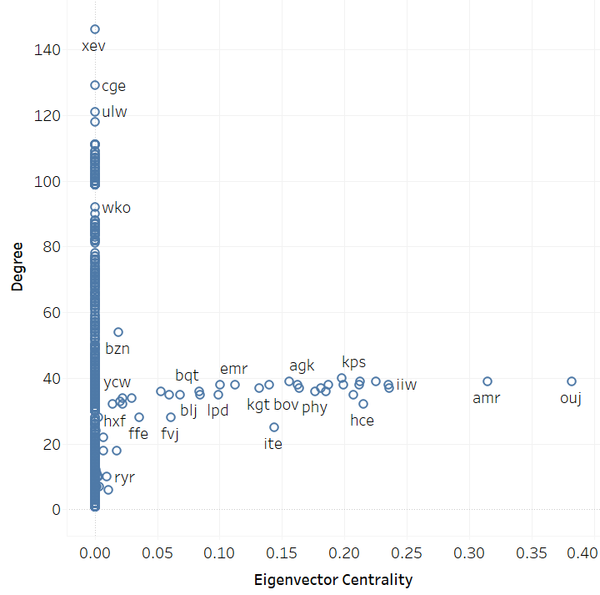

**Figure 10.** Scatter plot of degree and eigenvector centrality

In addition, other than developer ‘ouj’, ‘amr’ and ‘iiw’ are another two developers having high eigenvector centrality scores, while developer ‘xev, ‘cge’ and ‘ulw’ have the lowest. Furthermore, as it shown in figure 11, developer ‘ouj’,’amr’ and ‘iiw’ are intensively sharing projects. It can be therefore implied that those shared projects are worked by a lot of high-quality developers, bringing those three developers high-quality neighbors and thus high eigenvector centrality.

On the contrary, as it shown in figure 12, developer ‘cge’ and ‘ulw’ share only one project, ‘KGD’. It thus suggests that ‘KGD’ is a project worked by plenty of low-quality developers, giving both ‘cge’ and ‘ulw’ low-quality neighbors and thus low eigenvector centrality.

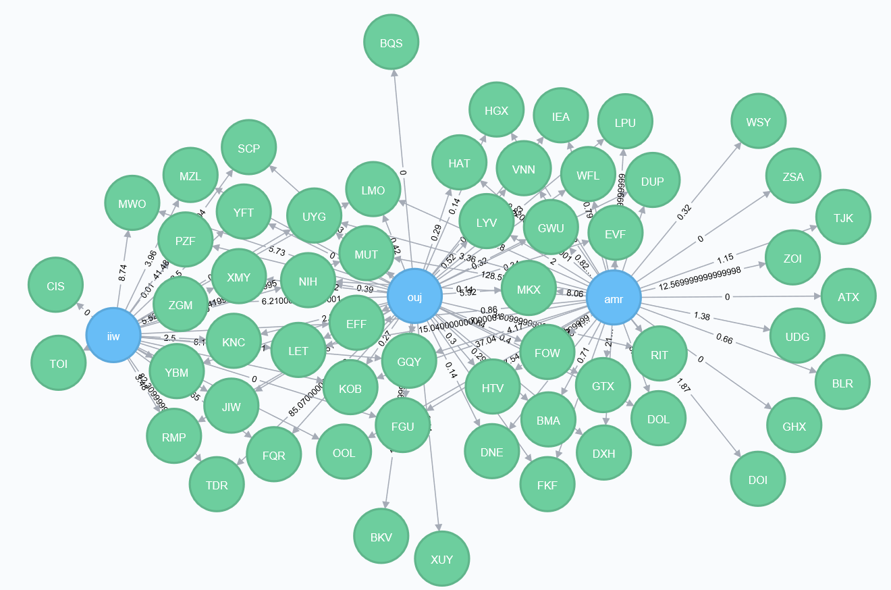

**Figure 11.** Developer ‘ouj’,’amr’ and ‘iiw’ and their connections

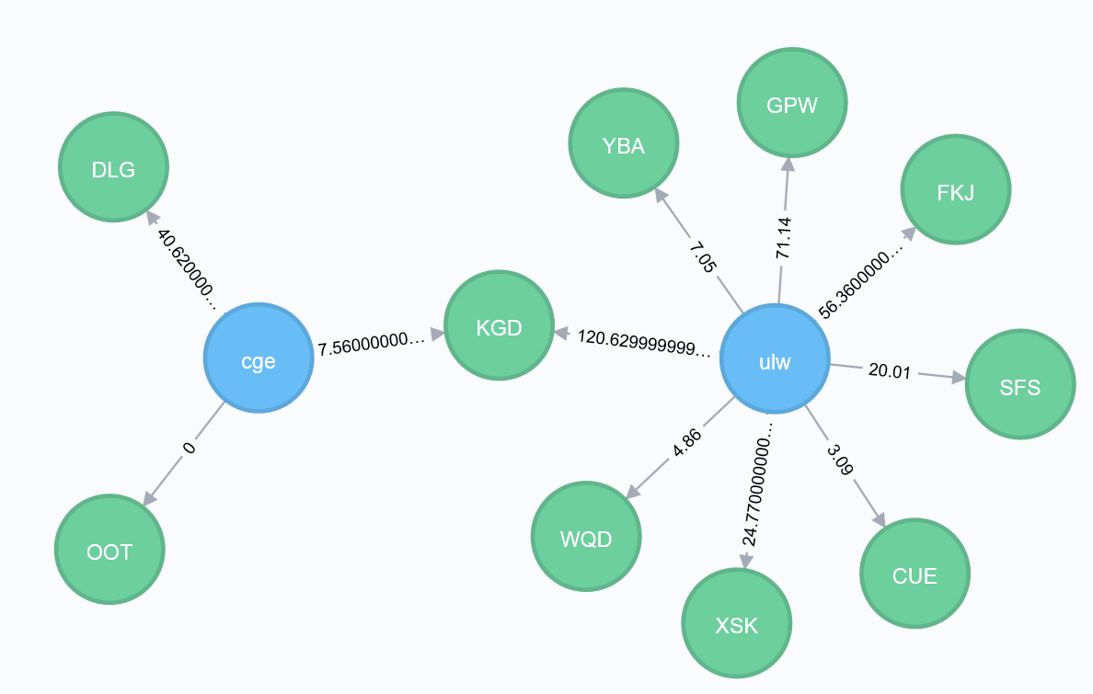

**Figure 12.** Developer ‘cge’ and ‘ulw’ and their connections

* 1. **Community Detection**

Communities in a network are groups of nodes internally connected or nodes sharing attributes. (Girvan and Newman 2002) Detecting communities provides insights regarding the overall network structure, behavioral patterns of nodes and their relations. (Fortunato 2010, Malliaros and Vazirgiannis 2013) For the developer-developer network, it supports findings about developers’ roles, collaboration preference as well as corporate cohesion. (Porter, Onnela and Mucha 2009)

However, community detection, also called graph or network clustering, is an ill-defined problem. ([Fortunato](https://arxiv.org/find/physics/1/au:+Fortunato_S/0/1/0/all/0/1) and [Hric](https://arxiv.org/find/physics/1/au:+Hric_D/0/1/0/all/0/1) 2016) There is no universal definition of the methodology that one should follow. Consequently, there are no clear-cut guidelines on how to evaluate and compare the performance of different algorithms.

Here we apply some popular and easy-accessible algorithms and compare their performance. More details on network clustering can be found in several review articles (Chakraborty et al., 2016; Coscia et al., 2011; Fortunato, 2010; Malliaros and Vazirgiannis, 2013; Newman, 2012; Parthasarathy et al., 2011; Porter et al., 2009; Schaeffer, 2007; Xie et al., 2013).

Algorithms we apply falls into three categories: optimization based, statistical inference based and dynamics based.

* + 1. **Optimization Based**

The idea of optimization based techniques is to optimize a quality function which measures the goodness of a clustering over all possibilities. (Fortunato 2010) The most widely-used quality function is modularity by Newman and Girvan (Newman 2006). It was designed to measure the strength of division of a network into communities. Networks with high modularity have dense connections between the nodes within modules but sparse connections between nodes in different modules.

The multi-level modularity optimization algorithm is based on the modularity measure and a hierarchical approach (Blondel et al 2008). It works according to the following steps: firstly, each node is assigned to a community independently. Secondly, each node is moved to the community in a local, greedy way, where it achieves the highest contribution to modularity. Thirdly, when no node can be reassigned, each community is considered as a node on its own, and repeat the second step. The process stops either when there is only one node left or when the modularity cannot be increased any more.

The algorithm can be applied to weighted undirected graphs. According to the Multi-Level algorithm, the largest community in the developer-developer network contains 173 developers while the smallest (six communities) consists of just two developers. On average, communities contain 98 developers. Figure 13 displays 172 groups with different colors, among which the largest group is colored in black.

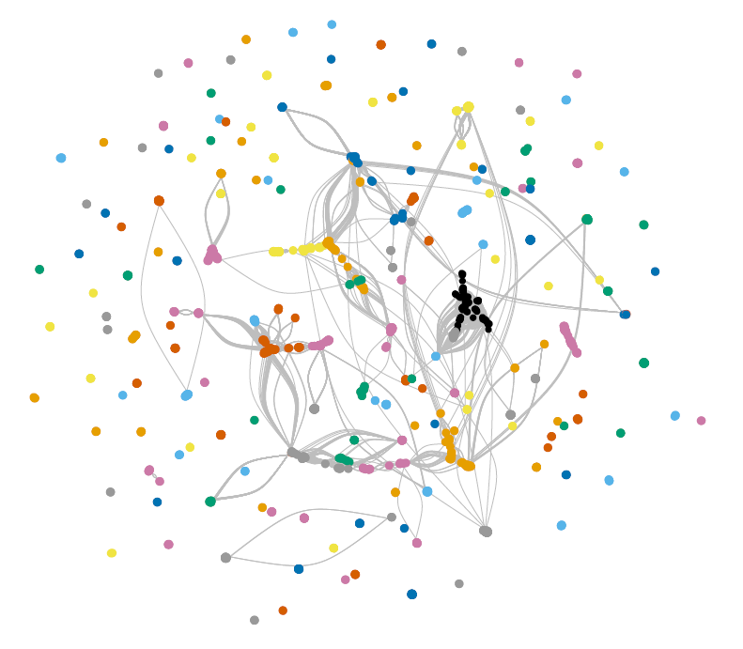

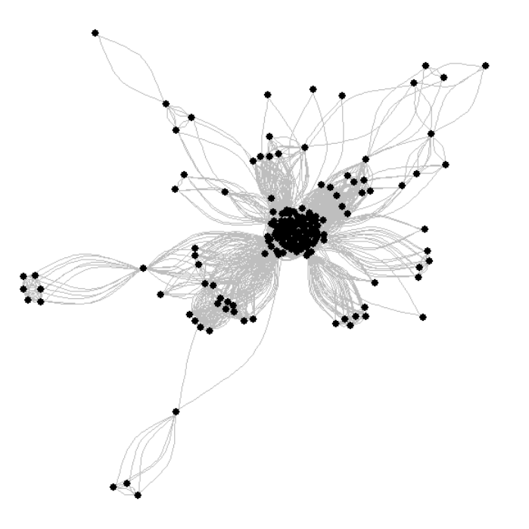

**Figure 13.** Visualization of community detection in the developer’s network

However, it has been proved that modularity suffers a resolution limit and, therefore, it is unable to detect small communities. (Fortunato 2010)

* + 1. **Statistical Inference Based**

Statistical inference is another popular method for community detection. The standard approach is to fit [generative models](https://en.wikipedia.org/wiki/Generative_model) whose parameters can be inferred from data. (Ball et al., 2011; Guimer`a and Sales-Pardo, 2009; Hastings, 2006; Karrer and Newman, 2011). To find parameters for a best-fitted model, we use Minimum description length (MDL), which measures the amount of [information](https://en.wikipedia.org/wiki/Information_theory) required to describe the data. This approach corresponds to an implementation of [Occam’s razor](https://en.wikipedia.org/wiki/Occam%27s_razor), where the simplest model is selected, among all possibilities with the same explanatory power. (Rissanen 1978)

The [stochastic block model](https://en.wikipedia.org/wiki/Stochastic_block_model) is arguably the simplest generative process based on the notion of groups of nodes (holland et al 1983). There are two types of [stochastic block model](https://en.wikipedia.org/wiki/Stochastic_block_model): non-degree-corrected and degree-corrected. Non-degree-corrected model assumes that the edges are placed randomly inside each group, and as such the nodes that belong to the same group have very similar degrees. Therefore, the model usually performs bad on networks possessing highly heterogeneous degree distributions.  The degree-corrected model provides a better fit for many empirical networks. (Karrer and Newman 2011).

Table 6 shows the performance of stochastic block models on the developer-developer network.

|  |  |  |
| --- | --- | --- |
| **Algorithm** | **Minimum description length** | **Group Number** |
| *Non-degree-correlated stochastic block model* | 68796.50778086044 | 52 |
| *degree correlated stochastic block model* | 67503.250630552488 | 61 |

**Table 6:** Degree correlated stochastic block model performs better than non-degree-correlated model based on minimum description length

A regular SBM has a drawback when applied to very large networks: it can’t find relatively small groups in very large networks. To address this problem, the nested stochastic block model (Peixoto 2014) was introduced. It not only finds small groups in large networks, but also provides a multilevel hierarchical description of the network. Table 7 demonstrates the results of nested stochastic block models on the developer-developer network.

|  |  |  |
| --- | --- | --- |
| **Algorithm** | **Minimum description length** | **Inferred Hierarchy** |
| *Non-degree-correlated nested stochastic block model* | 58349.392019931613 | 7 |
| *degree correlated nested stochastic block model* | 58447.470967214511 | 6 |

**Table 7:** Non-degree correlated stochastic block model performs better than degree-correlated model based on minimum description length

Although it is often true that the degree-corrected model provides a better fit for many empirical networks, there are also exceptions. As it shown in table 7, non-degree-correlated nested stochastic block model generates lower minimum description length on the concerned developer-developer network than the degree-correlated nested stochastic block model.

* + 1. **Dynamics Based**

Communities can also be identified by running dynamical processes on the network. (Fortunato 2010) Considering that Random walk dynamics is by far the most exploited in community detection, in this section we implement Walktrap (Pons and Latapy, 2006) and Infomap.

Walktrap and Infomap are methods both based on random walks. The former is based on the fact that short random walks have the tendency of staying in the same community while the latter tries to build a grouping which provides the minimum description length for a random walk on the graph. (Pons and Latapy, 2006)

Table 4 shows the results of dynamics based algorithms applied on developer-developer network.

|  |  |  |
| --- | --- | --- |
| **Algorithm** | **Modularity** | **Groups** |
| Walktrap | 0.96 | 193 |
| Infomap | 0.16 | 1119 |

**Table 8:** Walktrap generates a much higher modularity and smaller group numbers than Infomap

A comprehensive and optimized way of inferring network structure through community detection is beyond the scope of this paper. Here we apply some easy-accessible algorithms categorized as optimization based, statistical inference based and dynamics based as attempts to simplify and characterize the structure of a complex network.

## Summary

To understand the interaction among developers, we create a weighted developer-developer graph by projecting the weighted bipartite developer-project graph. Four graph properties, namely degree, closeness, betweenness and eigenvector centrality, are studied, from which we achieve implications about developers’ functionality, roles and relationships. In addition, we compare and implement different community detection algorithms, such as popular modularity maximization approach, to categorize and capture the network structure.

# Modeling Dynamics: Evolving Network

Analyzing dynamic network has gained increase popularity and significance as longitudinal network data becomes more available. Organizations study corporate network in a dynamic way in order to discover the decision cycle of major events, track the evolutions of corporate finances, operations and culture, as well as detect changes in the organizational behavior. Being able to identify a change in network dynamics can enable managers to better prepare for the coming change and prevent potential problems. (Doreian and Stokman 1997)

Dynamic network analysis (DNA) brings together traditional social network analysis, link analysis, social simulation and multi-agent systems within network science and network theory.

(Majdandzic et al 2013). There are two aspects of this field. The first is the statistical analysis of DNA data. The second is the utilization of simulation to address issues of network dynamics. Dominant modeling methods include Markov chain models, multi-agent simulation models, and statistical models. (McCulloh and Carley 2009)

A complete application of dynamic network modeling is beyond the scope of this paper. Considering the nature of the given problem, we choose statistical models as our major measure. In other words, we compare the properties of networks at different points in time.

[figures of graph at different time points]

[density trend (daily), waiting to be modified, expecting zero on weekends…]

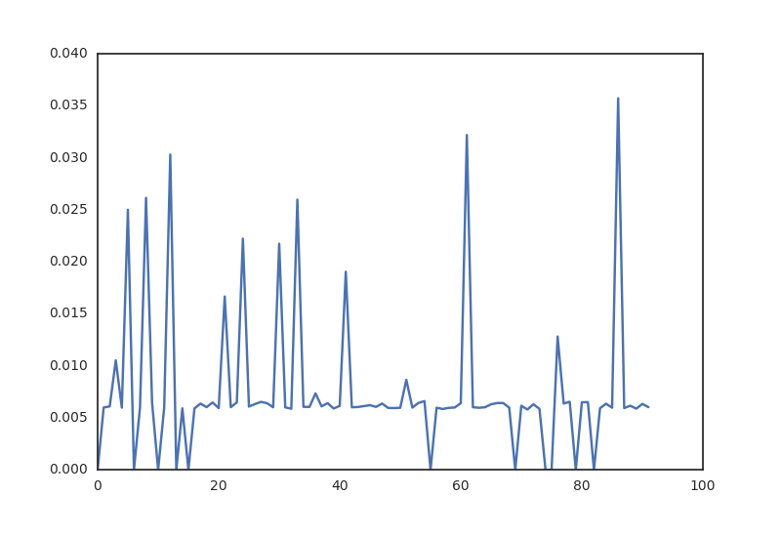

# Discussion and concluding remarks

Network data science is the use of data science methods, tools and algorithms in the modeling and analysis of network (graph) data. We demonstrated how a network data science approach can help companies gain rich insights about employee effort, contribution, and collaboration. These insights are useful in order to optimize work patterns and productivity in organizations.

# A study of the proprietary software development was started with constructing weighted graphs. Afterwards, initial insights about developers’ role (managers or engineers), productivity and individual influence were achieved through analyzing network properties. Finally, implications about software development cohesion and culture were developed through implementation of cluster analysis as well as a comparison between constructed networks and complex systems.

In addition to the analysis of network data, we proposed a recommender system that managers could consult to assign employees to projects…

# In addition to the analysis of a snapshot or aggregated version of the software development network at this particular company, we did a longitudinal and dynamic analysis. This provides better understanding of how node attach and detach from the network (developers dropping off or initiating projects), and thus lead to a more thorough understanding of developers’ working pattern.

There are many opportunities for future research to extend the methodology proposed in this paper. …

# References

Albert R., Barabasi A.-L. (2002). Statistical mechanics of complex networks. Rev. Mod. Phys. 74: 47–97.

Ball, B., B. Karrer, and M. E. J. Newman, 2011, Phys. Rev. E 84, 036103.

Brian Karrer, and M. E. J. Newman (2011). Stochastic Blockmodels and Community Structure in Networks. Physical Review E 83, no. 1 (2011): 016107

Chakraborty, T., A. Dalmia, A. Mukherjee, and N. Ganguly, 2016, preprint arXiv:1604.03512.

Coscia, M., F. Giannotti, and D. Pedreschi, 2011, Stat. Anal. Data Min. 4(5), 512.

Clauset, A.; Shalizi, C. R., Newman, M. E. J. (2009). "Power-Law Distributions in Empirical Data". SIAM Review. 51 (4): 661–703. arXiv:0706.1062Freely accessible. Bibcode:2009 SIAMR..51..661C. doi:10.1137/070710111.

Darst, R. K., Z. Nussinov, and S. Fortunato, 2014, Phys. Rev. E 89(3), 032809.

Doreian, P., and Stokman, F.N. (Eds.) (1997). Evolution of Social Networks. Amsterdam: Gordon and Breach.

Fani, Hossein; Bagheri, Ebrahim (2017). Community detection in social networks. Encyclopedia with Semantic Computing and Robotic Intelligence. 1. pp. 1630001 [8].

F. D. Malliaros; M. Vazirgiannis (2013). Clustering and community detection in directed networks: A surve. Phys. Rep. 533 (4): 95–142.

Francesco Ricci, Lior Rokach, Bracha Shapira, [Introduction to Recommender Systems Handbook](http://www.inf.unibz.it/~ricci/papers/intro-rec-sys-handbook.pdf), Recommender Systems Handbook, Springer, 2011, pp. 1-35

Guillaume, J., Latapy, M. (2004). Bipartite structure of all complex networks. Information Processing Letters, 90(5):215-221.

Guimer`a, R., and L. A. N. Amaral, 2005, Nature 433, 895.

Hastings, M. B., 2006, Phys. Rev. E 74(3), 035102.

Hazewinkel, Michiel, ed. (2001), Kolmogorov–Smirnov test,  [Encyclopedia of Mathematics](https://en.wikipedia.org/wiki/Encyclopedia_of_Mathematics), Springer, [ISBN](https://en.wikipedia.org/wiki/International_Standard_Book_Number) [978-1-55608-010-4](https://en.wikipedia.org/wiki/Special:BookSources/978-1-55608-010-4)]

Ian McCulloh and Kathleen Carley (2009). Longitudinal Dynamic Network Analysis. CMU-ISR-09-118

J.S. Breese, D.Heckerman, and C.Kadie. Empirical analysis of predictive algorithms for collaborative filtering. In Proceedings of the Fourteenth Conference on Uncertainty in Artifical Intelligence, 1998.

Karrer, B., E. Levina, and M. E. J. Newman, 2008, Phys. Rev. E 77(4), 046119.

Malliaros, F. D., and M. Vazirgiannis, 2013, Phys. Rep. 533(4), 95.

M. A. Porter, J.-P. Onnela, P. J. Mucha (2009). Communities in Networks, Math. Soc. 56: 1082–1097, 1164–1166.

Marsaglia G, Tsang WW, Wang J (2003). Evaluating Kolmogorov's Distribution. Journal of Statistical Software. 8 (18): 1–4.

[M. E. J. Newman (2001), Scientiﬁc collaboration networks. II. Shortest paths, weighted networks, and centrality, PHYSICAL REVIEW E, vol. 64, 016132.](http://www-personal.umich.edu/~mejn/papers/016132.pdf)

M. Girvan; M. E. J. Newman (2002). Community structure in social and biological networks. Proc. Natl. Acad. Sci. USA. 99 (12): 7821–7826.

Newman, M. E. J. (2006). [Modularity and community structure in networks](https://www.ncbi.nlm.nih.gov/pmc/articles/PMC1482622). Proceedings of the National Academy of Sciences of the United States of America. 103 (23): 8577–8696.

Newswire (2013). BlueOptima Coding Effort Analytics Announces Support for Git. Retrieved from <https://www.newswire.com/blueoptima-coding-effort-analytics/252989>.

Parthasarathy, S., Y. Ruan, and V. Satuluri, 2011, in Social Network Data Analytics (Springer), pp. 79–113.

Pons, P., and M. Latapy, 2006, Computing Communities in Large Networks Using Random Walks. International Symposium on Computer and Information Sciences (Springer), pp. 284– 293

Paul W. Holland, Kathryn Blackmond Laskey, Samuel Leinhardt (1983). Stochastic blockmodels: First steps, Carnegie-Mellon University, Pittsburgh, PA 15213, U.S.A.

Rissanen, J. (1978). Modeling by shortest data description. Automatica. 14 (5): 465–658.

[Santo Fortunato](https://arxiv.org/find/physics/1/au:+Fortunato_S/0/1/0/all/0/1), [Darko Hric](https://arxiv.org/find/physics/1/au:+Hric_D/0/1/0/all/0/1) (2016). Community detection in networks: A user guide. arXiv:1608.00163 [physics.soc-ph]

Schaeffer, S. E., 2007, Comput. Sci. Rev. 1(1), 27.

S. Fortunato (2010). Community detection in graphs. Phys. Rep. 486 (3–5): 75–174.

Tiago P. Peixoto (2014). Hierarchical block structures and high-resolution model selection in large networks. Phys. Rev. X 4, 011047.

Vincent D. Blondel, Jean-Loup Guillaume, Renaud Lambiotte, Etienne Lefebvre (2008), Fast unfolding of communities in large networks. [arXiv:0803.0476](https://arxiv.org/abs/0803.0476) [physics.soc-ph].

Xie, J., S. Kelley, and B. K. Szymanski, 2013, ACM Comput. Surv. 45(4), 43:1.

Zhou Tao, Ren Jie, Matus Medo, Yi-Cheng Zhang (2007). Bipartite network projection and personal recommendation. PHYSICAL REVIEW E 76(4): 046115.